Пояснения к данным

Данные представляют собой выгрузку из Clickhouse в формате TSV.

**Набор колонок для metrics_collector:**

account_id, name, point, call_count, total_call_time, total_exclusive_time, min_call_time, max_call_time, sum_of_squares, instances, language, app_name, app_id, scope, host, display_host, pid, agent_version, labels

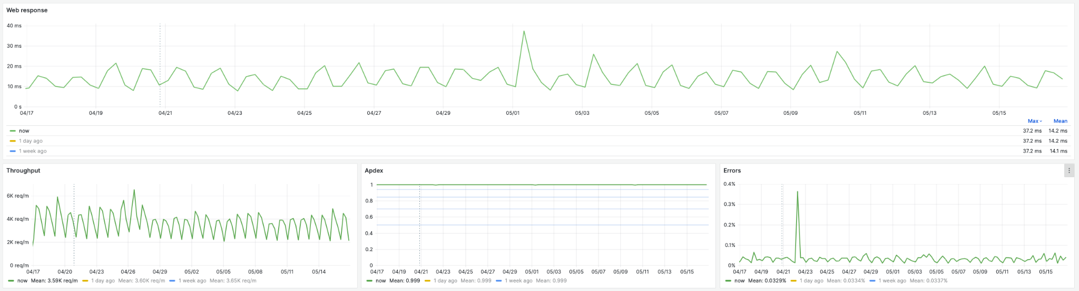

Ключевые метрик для анализа на первом этапе:

**Web Response** - время ответа сервиса на внешний http-запрос.  
select

point as time,

sumOrNull(total_call_time) / sumOrNull(call_count) as " "

from metrics_collector

where

language = 'java'

and app_name = '[GMonit] Collector'

and scope = ''

and name = 'HttpDispatcher'

group by time

order by time

**Throughput** - пропускная способность сервиса. Измеряется в запросах в минуту.  
select

point as time,

sumOrNull(call_count)

from metrics_collector

where

language = 'java'

and app_name = '[GMonit] Collector'

and scope = ''

and name = 'HttpDispatcher'

group by time

order by time

**APDEX** - сводный синтетический показатель “здоровья” сервиса. Изменяется от 0 до 1. Чем ближе к 1, тем лучше.   
with

sumOrNull(call_count) as s,

sumOrNull(total_call_time) as t,

sumOrNull(total_exclusive_time) as f

select

point as time,

(s + t/2) / (s + t + f) as " "

from metrics_collector

where

language = 'java'

and app_name = '[GMonit] Collector'

and scope = ''

and name = 'Apdex'

group by time

order by time

**Error** - процент ошибок в обработанных запросах.   
select

point as time,

sumOrNullIf(call_count, name='Errors/allWeb') / sumOrNullIf(call_count, name='HttpDispatcher') as " "

from metrics_collector

where

language = 'java'

and app_name = '[GMonit] Collector'

and scope = ''

and name in ('HttpDispatcher', 'Errors/allWeb')

group by time

order by time

**Примеры размеченных аномалии**

1 - Throughput2024-04-19 7:15:00 - 8:00:00 UTC

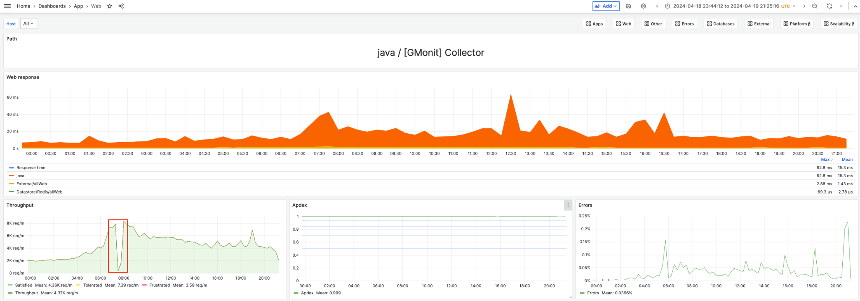

2 - Throughput2024-04-20 6:20:00 - 7:10:00 UTC   
 и далее, как следствие

Web Response2024-04-20 7:20:00 - 7:40:00 UTC

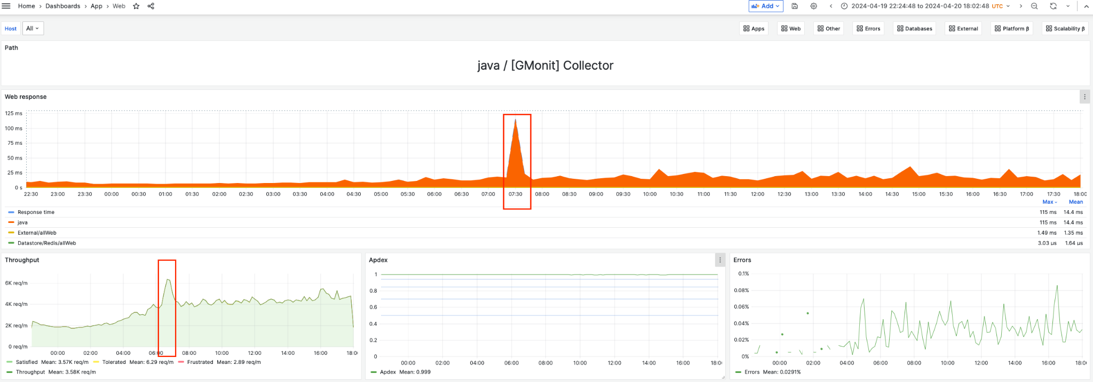

3 - Throughput2024-04-20 6:15:00 - 7:15:00 UTC   
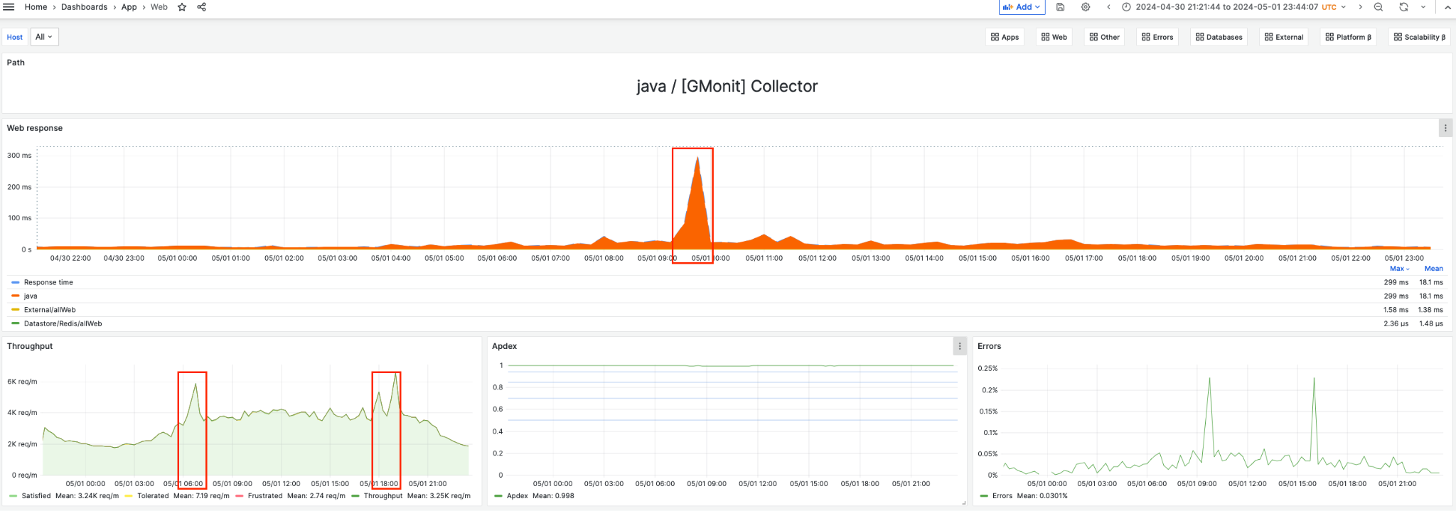

4 - Web Response2024-04-20 9:15:00 - 10:00:00 UTC